Tricolor

**Problem:**

On the occasion of our Independence Day, prime minister Narendra Modi is set to hoist our national flag at the Red Fort. The ceremony is being efficiently organised by the government officials. They want the flag support to be in the form of a pyramid with **N** steps. The $i^{th}$ step contains **2i-1** blocks, depicted as follows:

Each block has **X** number of flowers on it. The number of flowers follows a very special procedure: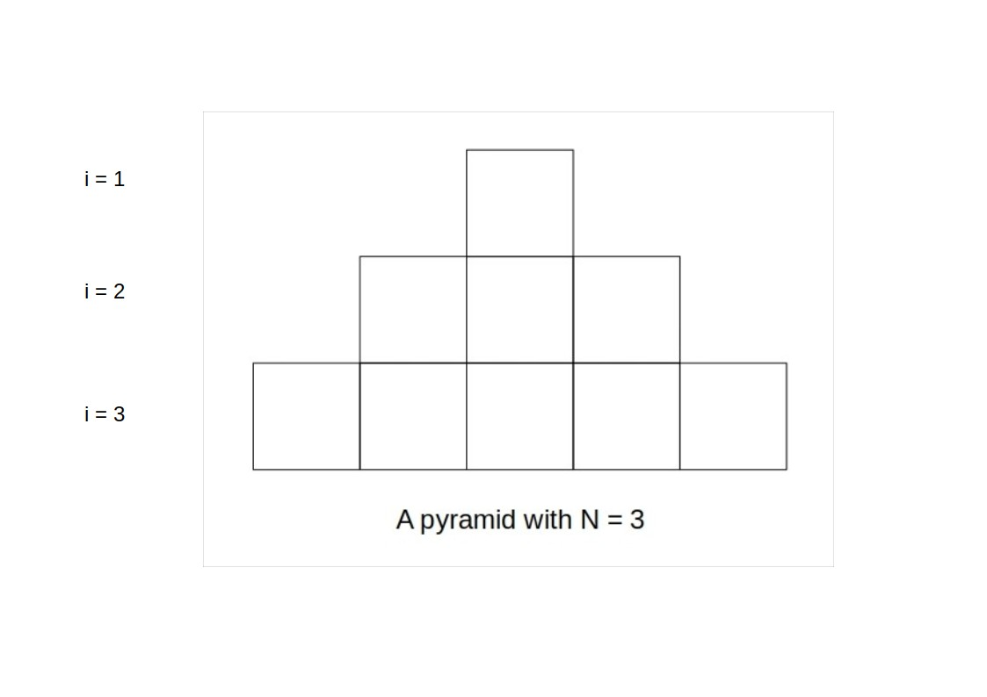

* The bottom most step has **2N-1** flowers, which is a permutation of **1** to **2N-1**
* At any level other than the bottom most one, the number of flowers in the block is the **median** of the number of flowers in the three blocks directly under it (Below-left, Below, Below-Right).

Given the number of flowers in each of the bottom most blocks, find the number of flowers in the top most block.

**Input:**

* The first line contains **N**, the number of steps.
* The next line contains **2N-1** integers ${A_{1....N}}_{}$, which denote the number of flowers in the bottom most blocks.

**Output:**

Print the number of flowers in the top most step.

**Constraints:**

$2 ≤ N ≤ 10^{5}$

* $A_{i}$ is a permutation of 1…..2N-1.

**Example:**

Input

3

1 3 2 4 5

Output

3

Explanation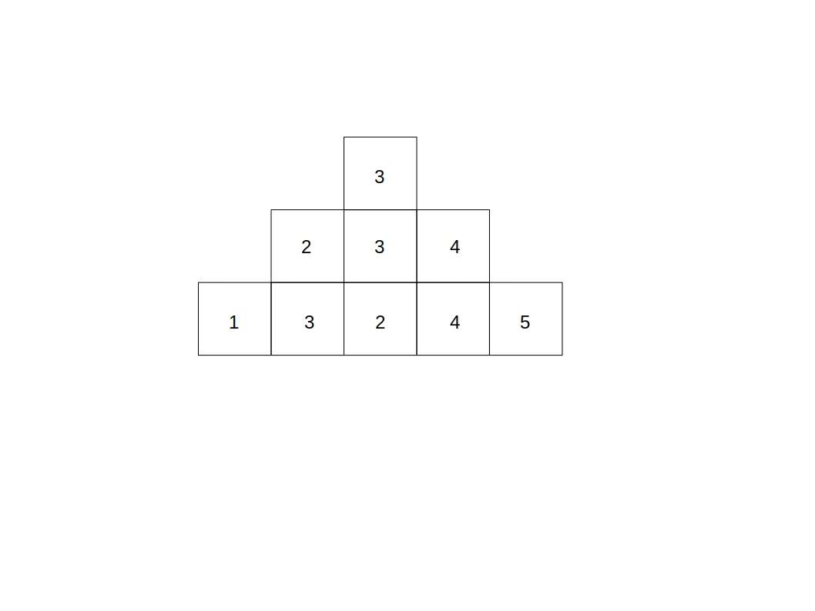

**Problem Setter:**

Sachinam_1397